

**DevOps and Its Advantages**

**Introduction**

In the rapidly evolving digital world, businesses demand faster software delivery, improved collaboration, and greater efficiency. Traditional software development models often created a “wall” between developers and operations teams, leading to delays, miscommunication, and inefficiencies. This is where **DevOps** comes into play.

DevOps is a combination of **“Development” and “Operations”**, representing a cultural shift and a set of practices that bring development and IT operations teams together. It focuses on **collaboration, automation, integration, and continuous delivery** to ensure reliable, faster, and more efficient software development.

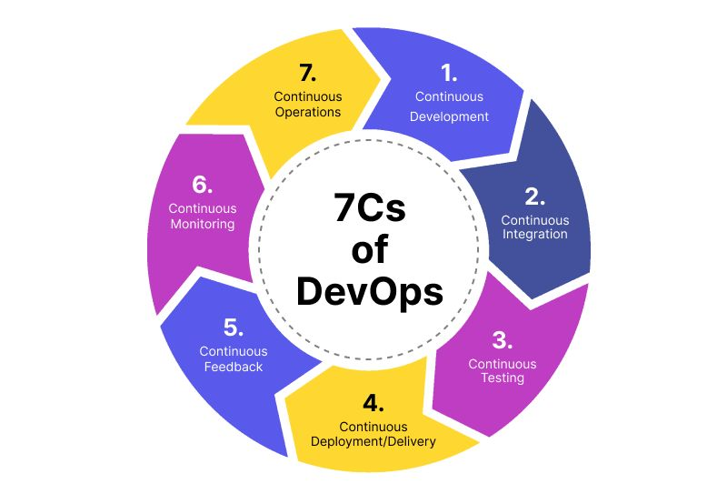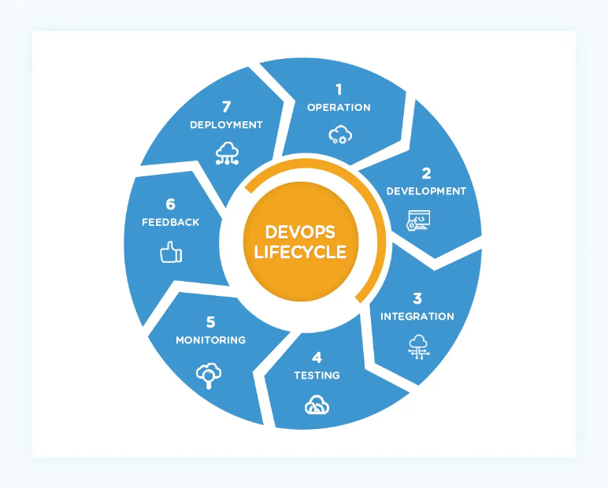

**Key Principles of DevOps**

1. **Collaboration and Communication** – Breaking silos between teams.
2. **Automation** – Automating repetitive processes such as testing and deployment.
3. **Continuous Integration and Continuous Deployment (CI/CD)** – Frequent code integration, testing, and faster deployment cycles.
4. **Monitoring and Feedback** – Continuous tracking of performance to improve quality.
5. **Infrastructure as Code (IaC)** – Managing infrastructure through code for consistency and scalability.

**Advantages of DevOps**

**1. Faster Delivery and Deployment**

DevOps ensures quick and frequent releases through automated testing and CI/CD pipelines. This reduces time-to-market, allowing businesses to respond rapidly to customer needs.

**2. Improved Collaboration and Efficiency**

By bridging the gap between developers and operations teams, DevOps promotes better communication, reduces conflicts, and improves overall productivity.

**3. Enhanced Reliability and Quality**

Continuous monitoring and automated testing help in detecting errors early, ensuring higher quality software and reducing system downtime.

**4. Scalability and Flexibility**

Through practices like Infrastructure as Code, DevOps enables organizations to scale resources up or down as required, making it easier to handle dynamic workloads.

**5. Better Security**

With integrated security practices (DevSecOps), vulnerabilities are identified and resolved earlier in the development cycle, reducing risks.

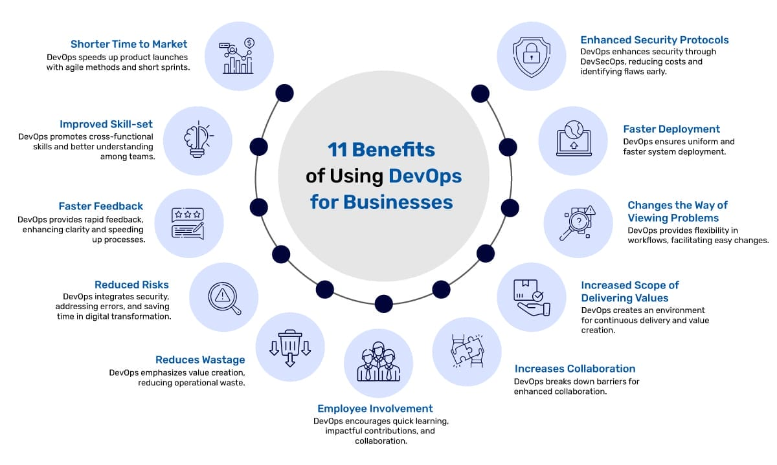

**Real-World Applications of DevOps**

* **Netflix** uses DevOps for continuous delivery and seamless user experiences.
* **Amazon** leverages automation and CI/CD to deliver software updates multiple times a day.
* **Facebook** uses DevOps practices for quick iteration and rolling out new features with minimal downtime.

**Conclusion**

DevOps is more than just a methodology; it is a **cultural transformation** that helps organizations achieve agility, reliability, and efficiency. By fostering collaboration, automation, and continuous delivery, DevOps empowers businesses to innovate faster and stay competitive in the digital landscape.